[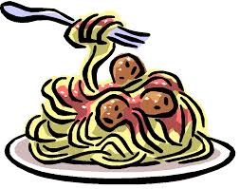](http://www.google.com/url?sa=i&source=images&cd=&cad=rja&uact=8&docid=1cubokJdnDWRAM&tbnid=us8hJGsOvbRMUM:&ved=0CAgQjRw&url=http://thevilla.org/2013/09/18/mother-cabrini-wants-you-to-eat-pasta/spaghetti-clipart-2/&ei=AmcgU422G8ni0gHj_IDICg&psig=AFQjCNH7cecpTQ1HTt7K_NcvNEKFeqVmPw&ust=1394718850624584)**St. Catharine of Siena School   
Spaghetti Dinner**

**It is not too late to purchase tickets for the spaghetti dinner being held on Saturday, April 18th from 4:00 – 8:00 P.M. at Casa Siena (Social Hall)!**

**If you cannot make the dinner, feel free to stop in and enjoy coffee, dessert and support our Chinese Auction.**

**Dinner Includes**

**Beverage, bread, salad, spaghetti and meatballs!**

**Dessert available for purchase.**

**Adult - $8.00 Children 10 & Under- $5.00 Children 2 and Under FREE**

**Take Out Available!**

**Tickets may be purchased at school and at the Door.**

**CHINESE AUCTION**

***Stop by Casa Siena (Social Hall) and help support SCS.* Cookies & Milk Classroom Party ~ Lords and Ladies $50 Gift Certificates ~ Pandora Charm Bracelet with “Faith Hope and Love “ Charm ~ Alex and Ani Bracelets ~ Wyomissing ATA Martial Arts and Karate for Kids (uniform and one MONTH of classes), and many more items.**

**Tickets Cost: 1 ticket for $1.00 ~ 6 tickets for $5.00 ~ 15 tickets for $10.00**